
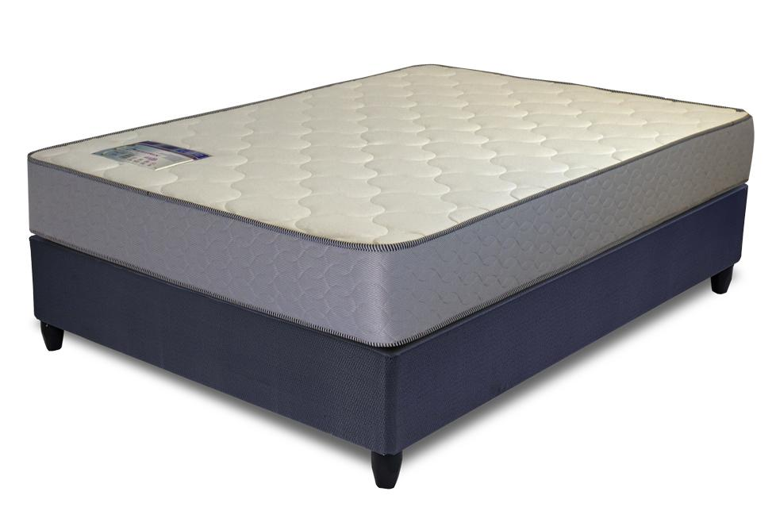

Model : Vito Base Set
Supplier/Manufacturer : Rest Assured
Range : Matrix
Prices – Bed Set :
- Single Bed Set – R3729
- Three Quarter Bed Set – R4189
- Double Bed Set – R4809
- Queen Bed Set – R5279
- King Bed Set – R6709
Prices – Mattress Only :
- Single Mattress Only – R2469
- Three Quarter Mattress Only – R2769
- Double Mattress Only – R3269
- Queen Mattress Only – R3649
- King Mattress Only – R4189
Prices - Extra Length Bed Set :
- Single Extra Length Bed Set – R4029
- Three Quarter Extra Length Bed Set – R4529
- Double Extra Length Bed Set – R5199
- Queen Extra Length Bed Set – R5709
- King Extra Length Bed Set – R7249
Prices - Extra Length Mattress Only :
- Single Extra Length Mattress Only – R2669
- Three Quarter Extra Length Mattress Only – R2989
- Double Extra Length Mattress Only – R3529
- Queen Extra Length Mattress Only – R3939
- King Extra Length Mattress Only – R4529

*Please use this link for guideline for creating the page* - https://ericssonsmattress.co.za/product/rest-assured-vito-base-set/?srsltid=AfmBOor7rvbUzkXtYyLw9eLxtEHZgXk7xgB4oRfIR6bp6UICnkZR3R1h
Rest Assured Link - https://restassured.co.za/our-ranges/matrix/vito/

